Expert Exam

# Time Series, Regression, Data Investigation, Classification, and Optimization

1. [How to Interpret Pr(>|t|) in Regression Model Output in R](https://www.statology.org/interpret-prt-regression-output-r/)
2. [How to Interpret Significance Codes in R](https://www.statology.org/significance-codes-in-r/)
3. [How to Calculate a P-Value from a T-Test By Hand](https://www.statology.org/how-to-calculate-a-p-value-from-a-t-test-by-hand/)
4. [Live Training: Regression Modeling](https://community.alteryx.com/t5/Videos/Regression-Modeling/td-p/113744)
5. [Mastering Time Series Analysis & Forecasting in Alteryx](https://www.phdata.io/blog/mastering-time-series-analysis-and-forecasting-in-alteryx/)
6. [Confusion Matrix](https://community.alteryx.com/t5/Data-Science/What-is-a-Confusion-Matrix/ba-p/537567)

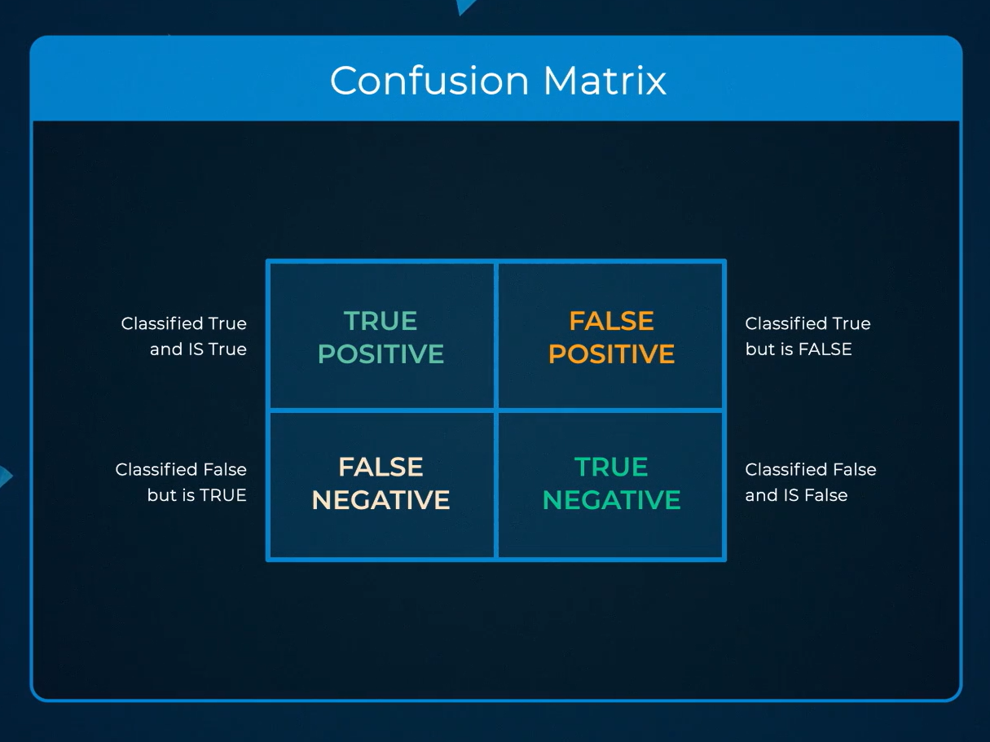





1. [Holdouts and Cross Validation: Why the Data Used to Evaluate your Model Matters](https://community.alteryx.com/t5/Data-Science/Holdouts-and-Cross-Validation-Why-the-Data-Used-to-Evaluate-your/ba-p/448982)
2. [Coefficient of determination](https://en.wikipedia.org/wiki/Coefficient_of_determination)
3. [How To: Complete Data Preparation And Investigation For Predictive Modeling](https://community.alteryx.com/t5/Alteryx-Designer-Knowledge-Base/How-To-Complete-Data-Preparation-And-Investigation-For/ta-p/545115)
4. [Cross Validation](https://en.wikipedia.org/wiki/Cross-validation_(statistics))
5. [Binomial coefficient](https://en.wikipedia.org/wiki/Binomial_coefficient)
6. [Knapsack problem](https://en.wikipedia.org/wiki/Knapsack_problem)
7. [Ljung-Box Test: Definition + Example](https://www.statology.org/ljung-box-test/)
8. [Pearson Correlation vs. Hoeffding’s D statistic](https://blogs.sas.com/content/iml/2021/05/03/examples-hoeffding-d.html)
9. Scatterplot

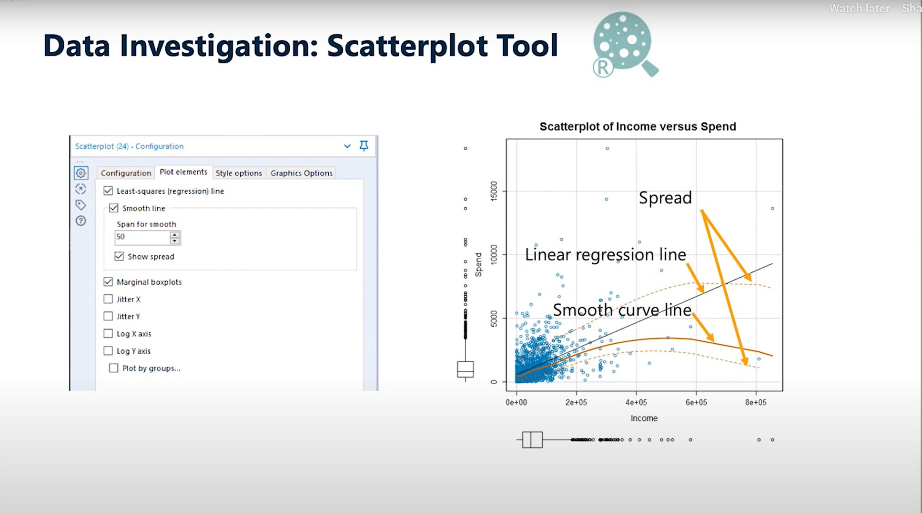

1. Plot of Means

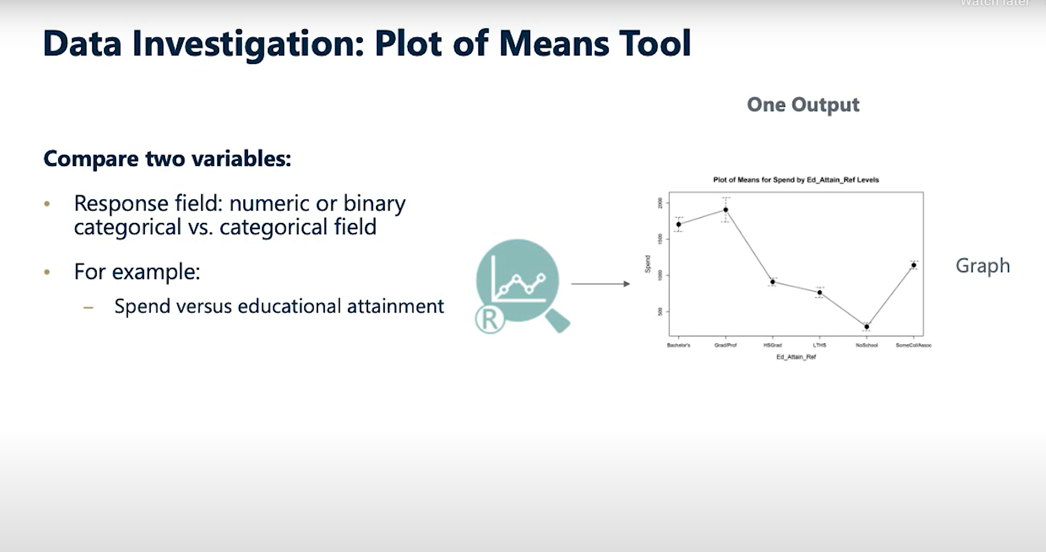

1. Action

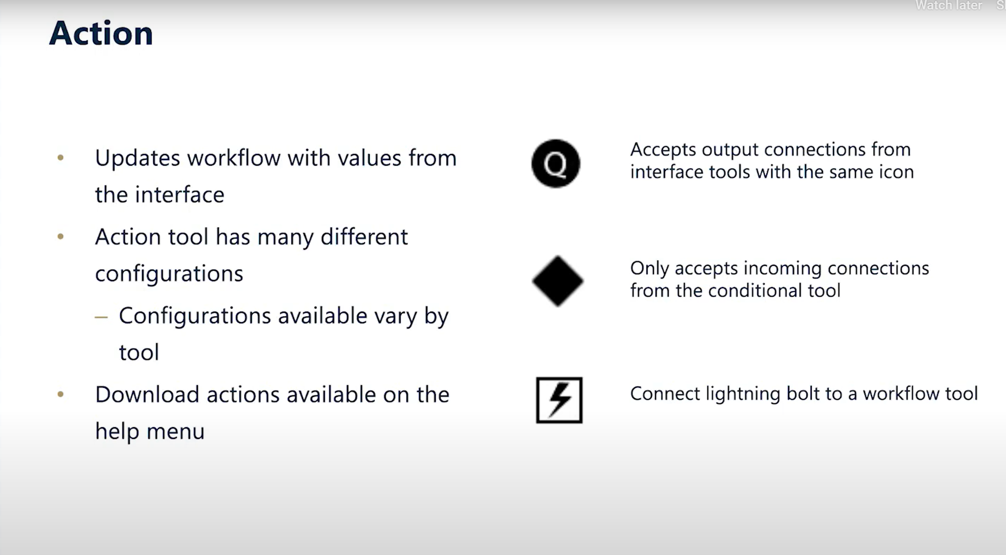

1. A model is a mapping of the relationships in your data.
2. Third step of creating a model is *Data Cleansing*.

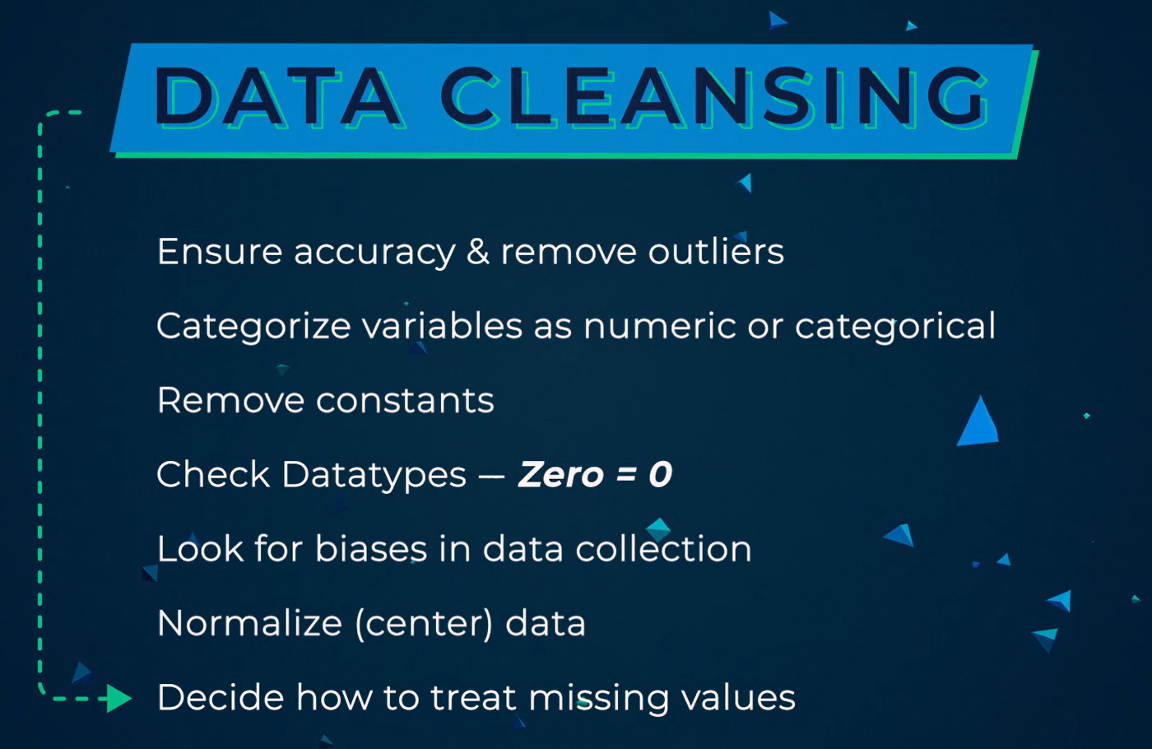

1. Modeling tools. The models in the middle can provide predictions for both categorical and continuous variables.

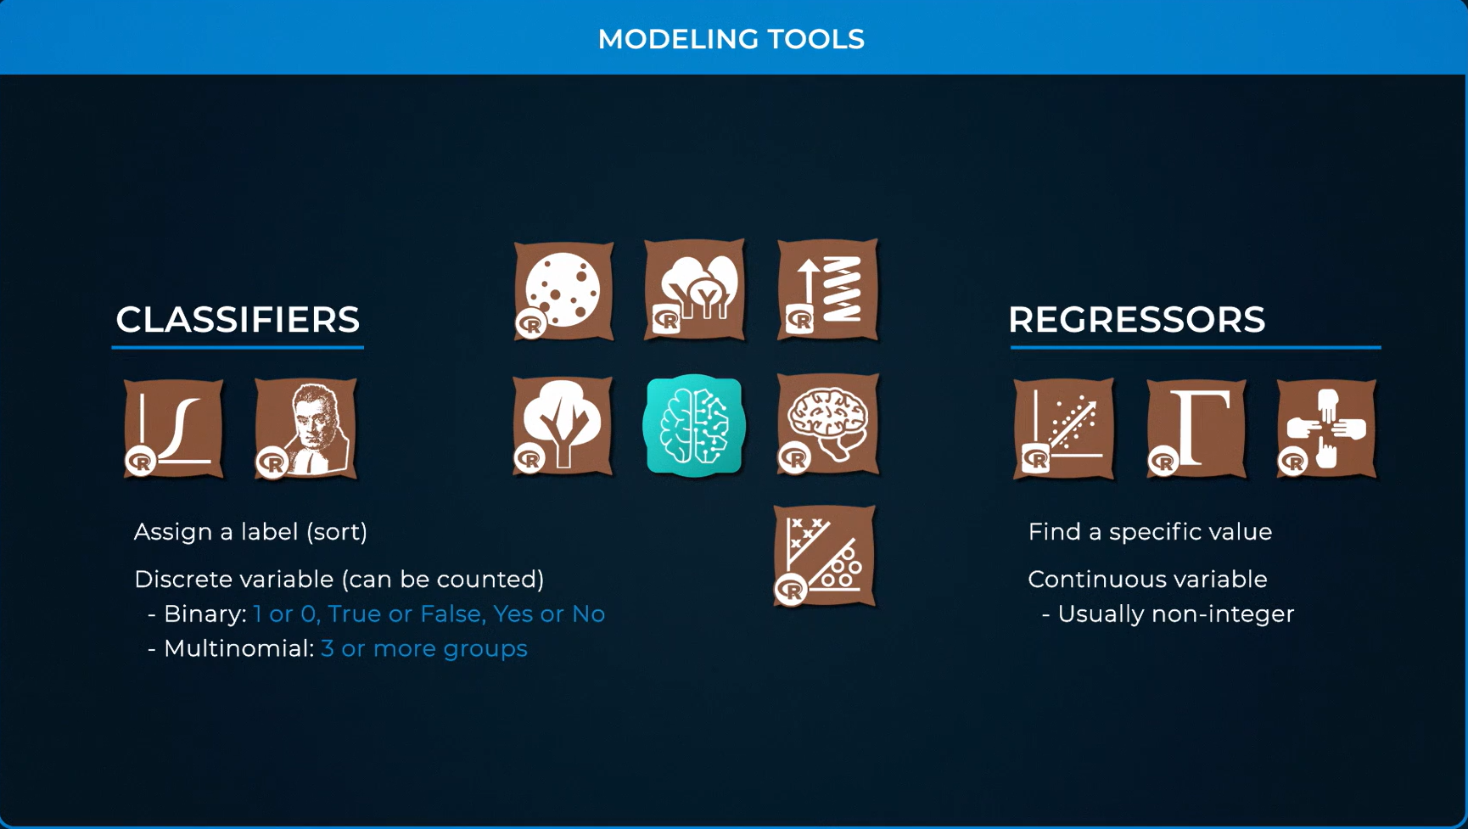

1. Manhattan vs Euclidean (aka “as the crow flies”):

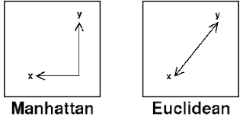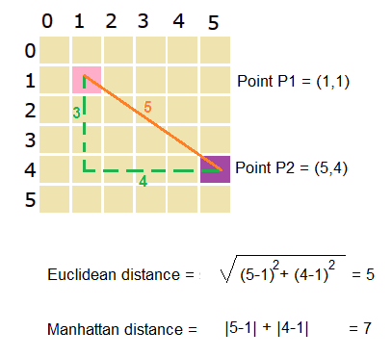

1. Collinearity

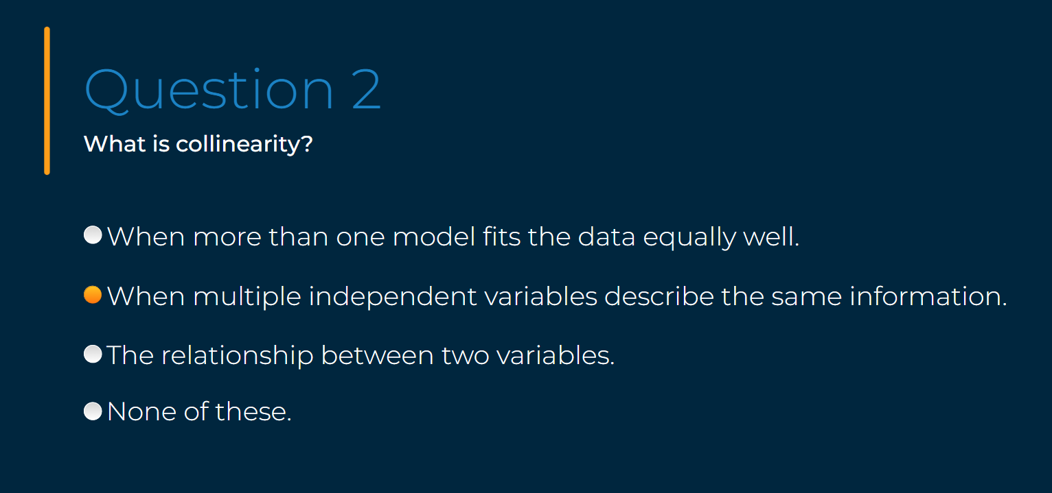

1. Area Under Curve (AUC)

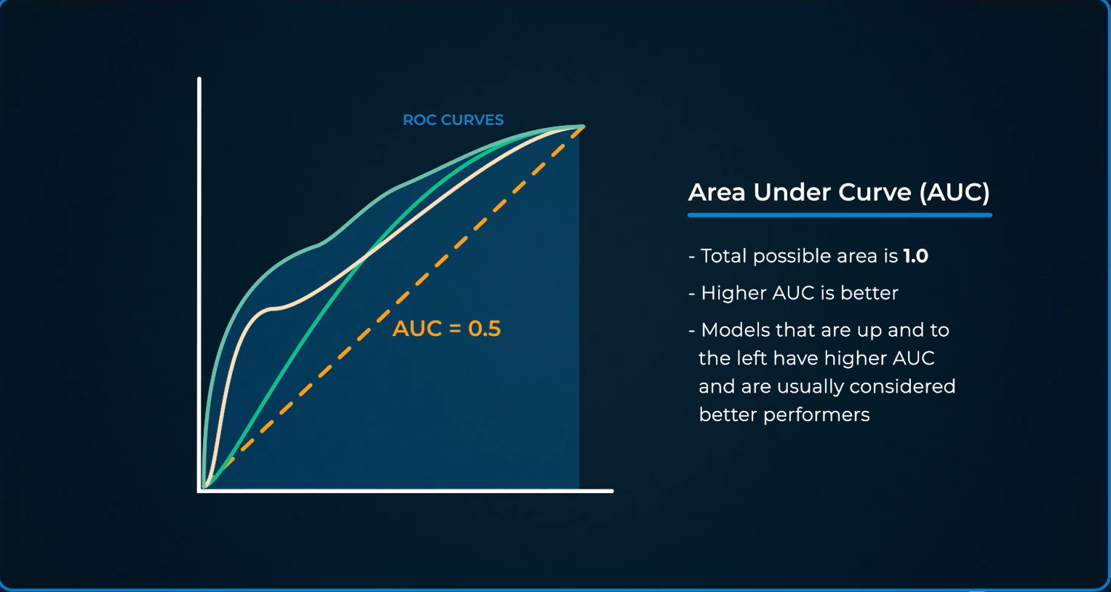

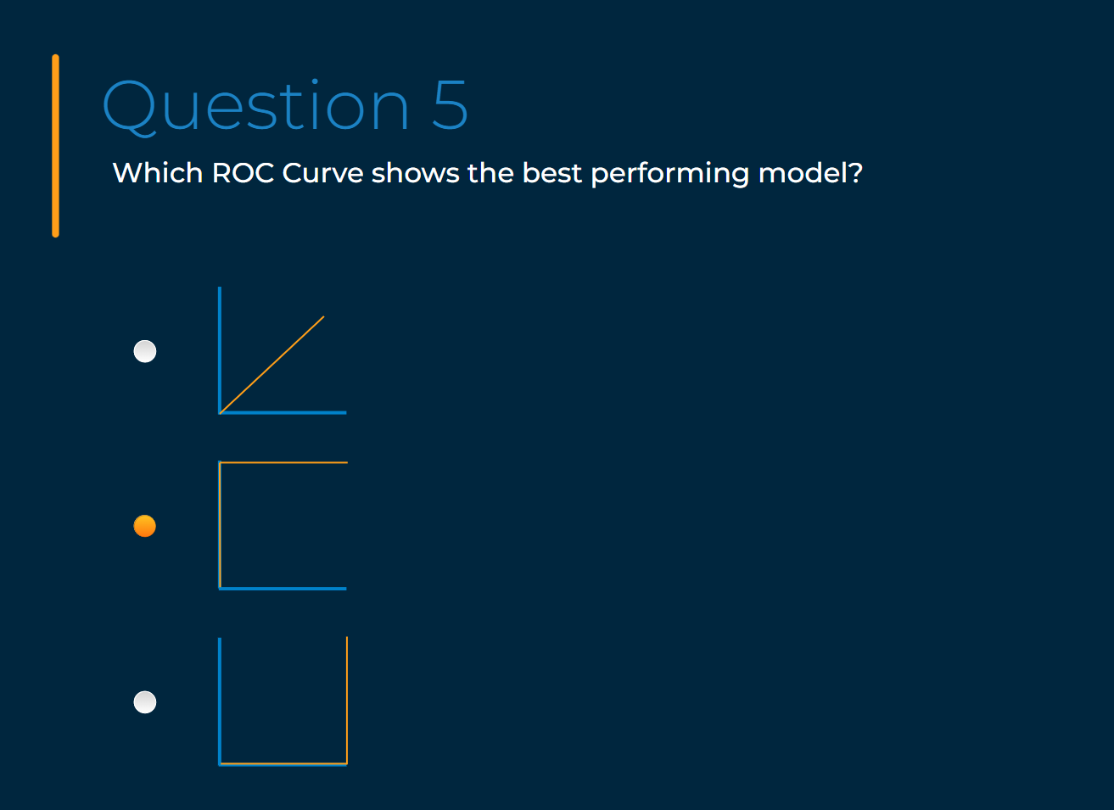

1. Confusion Matrix question (predicted in rows; actual in columns).

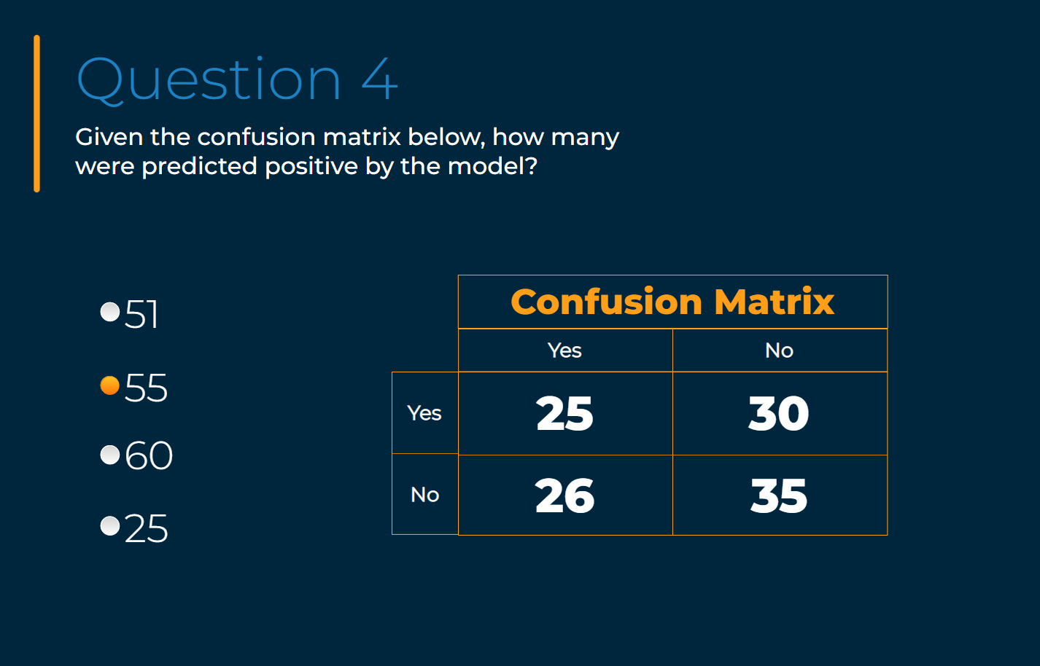

1. Predictive Analytics question

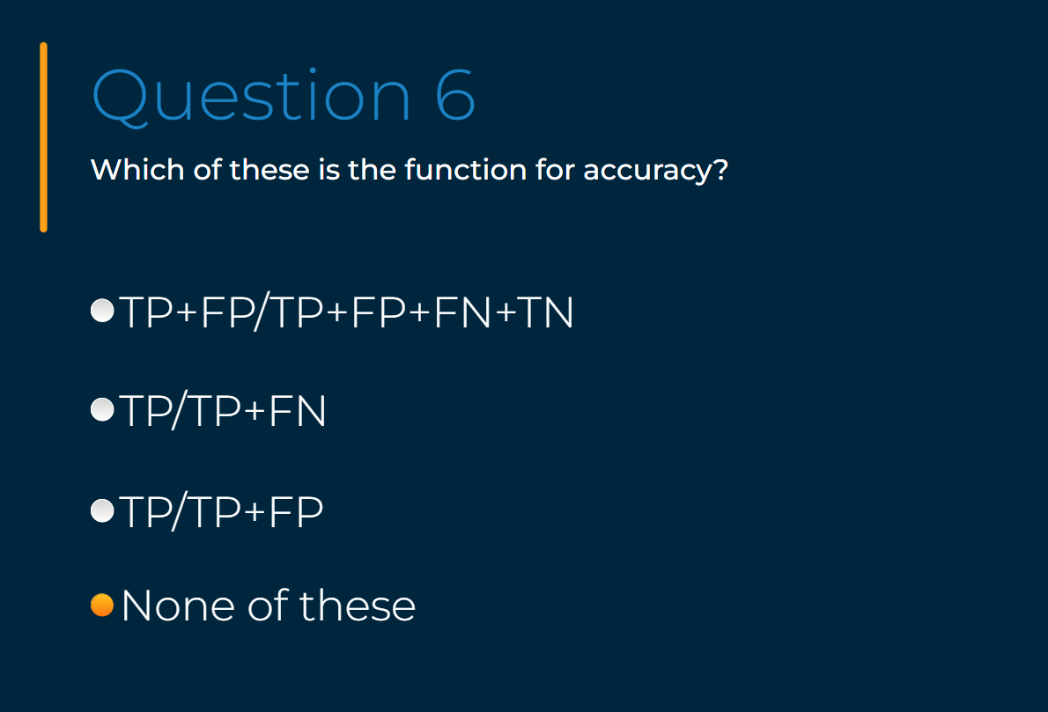

1. Data Investigation courses of action

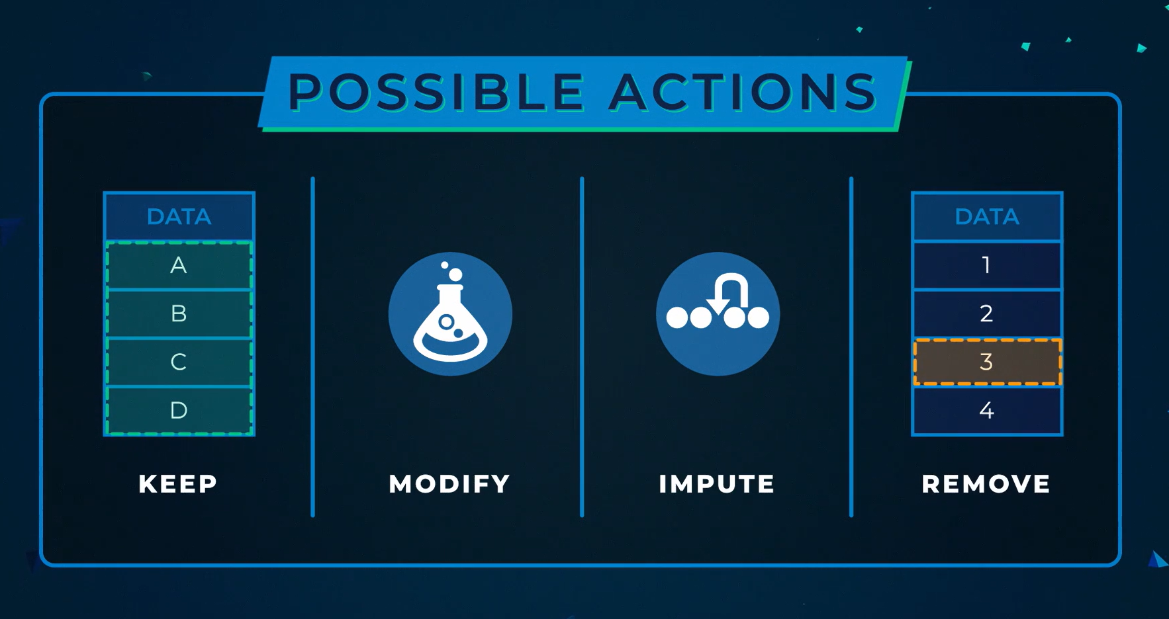

1. Bias & Skew

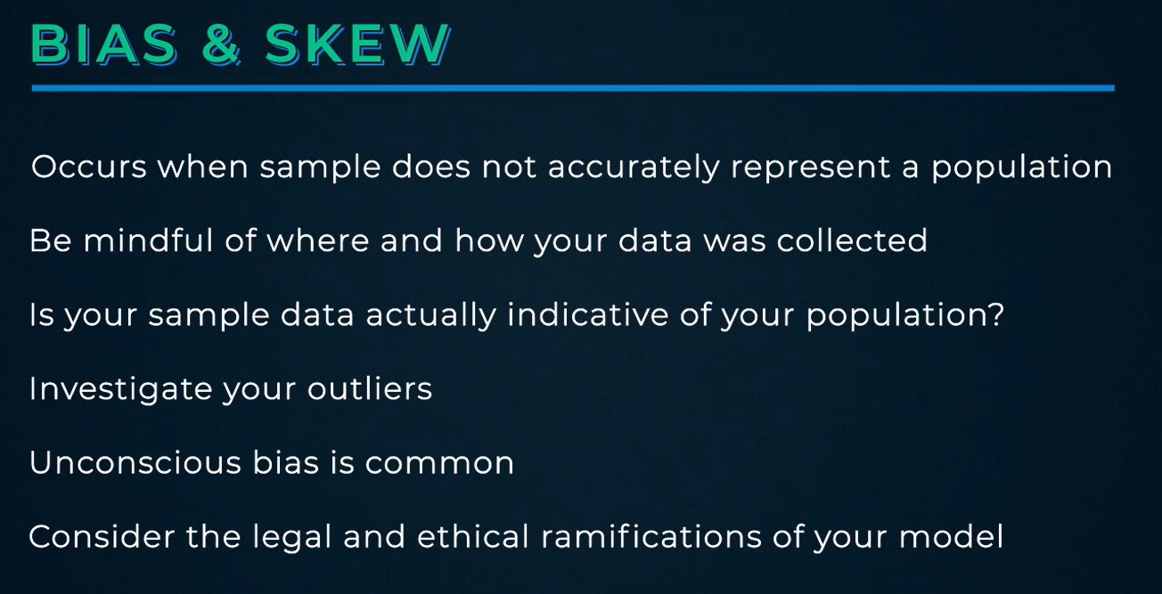

1. Frequency Table

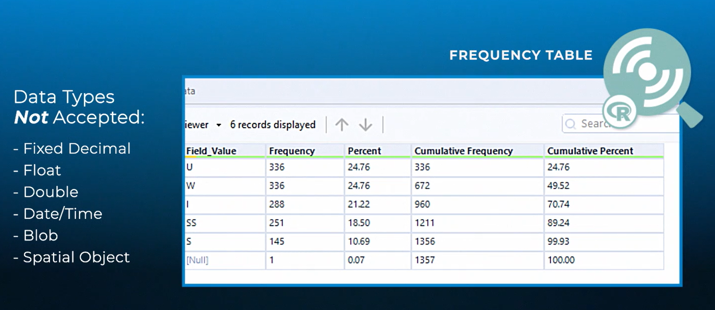

1. Scatterplot

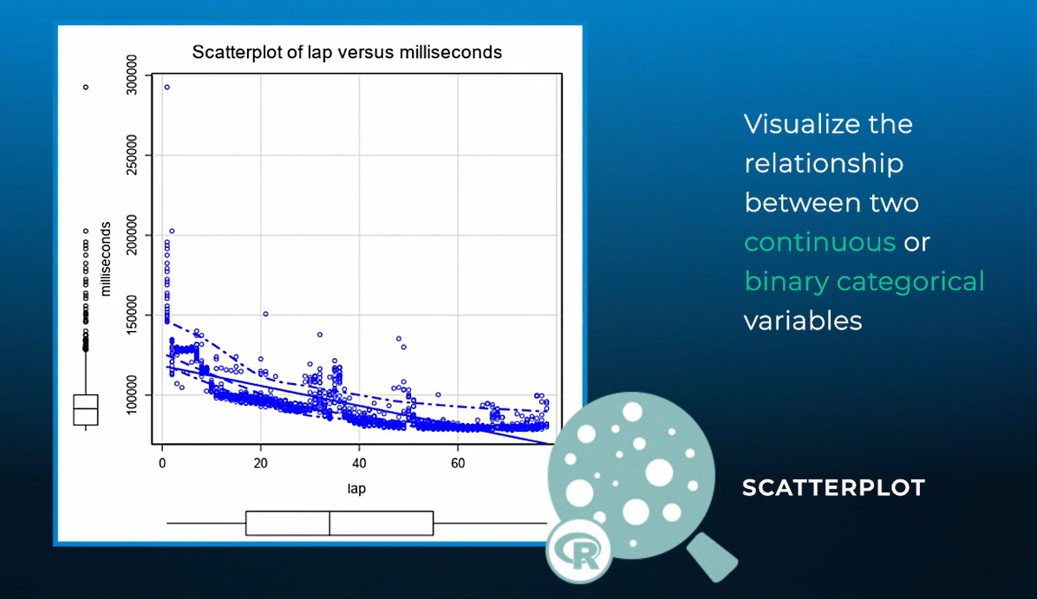

1. Pearson Correlation. Only works for linear relationships.

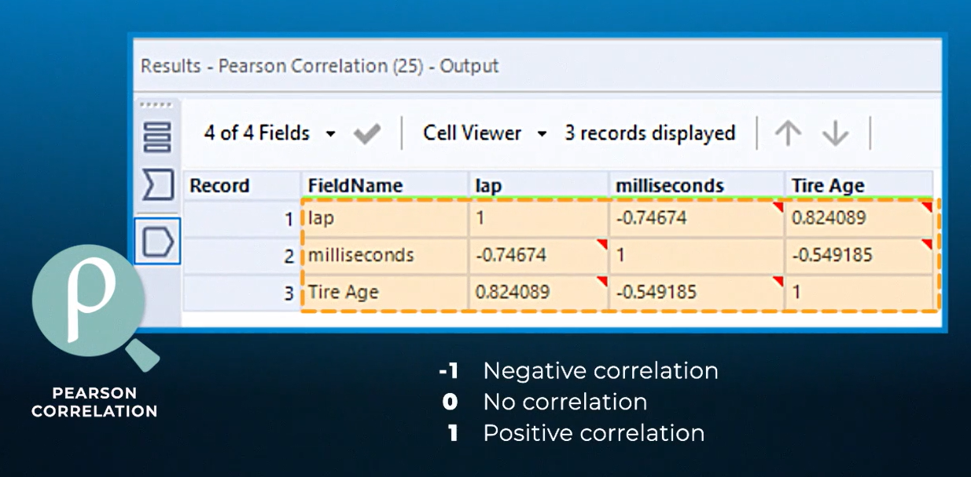

1. Spearman Correlation.

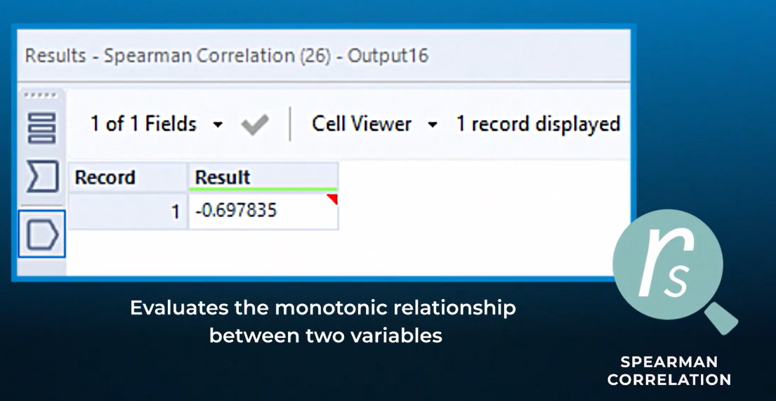

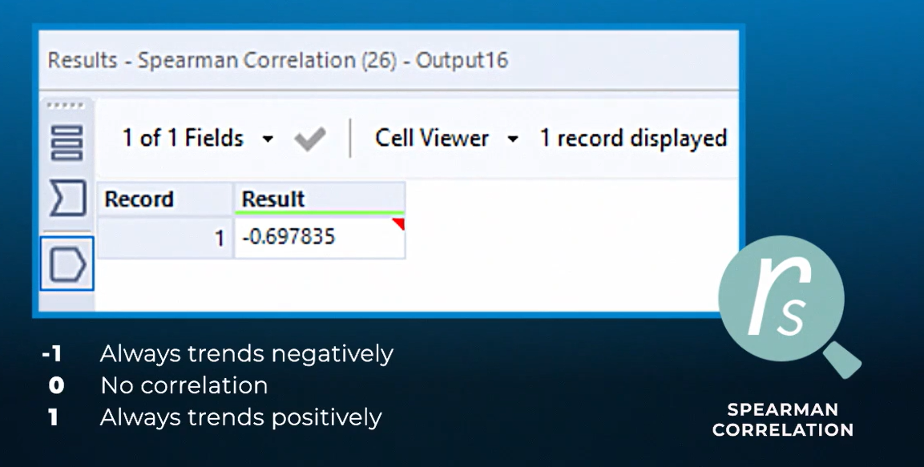



 **<-** Can’t say that *red* is a step up from *green*, but *large* IS greater than *small*.

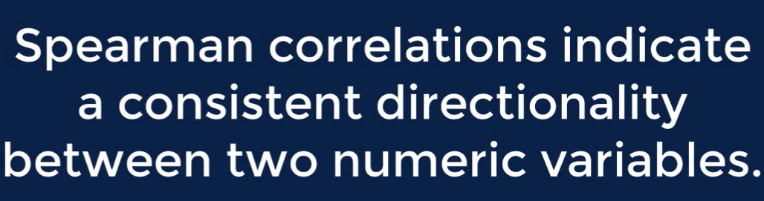

1. Data Investigation question.

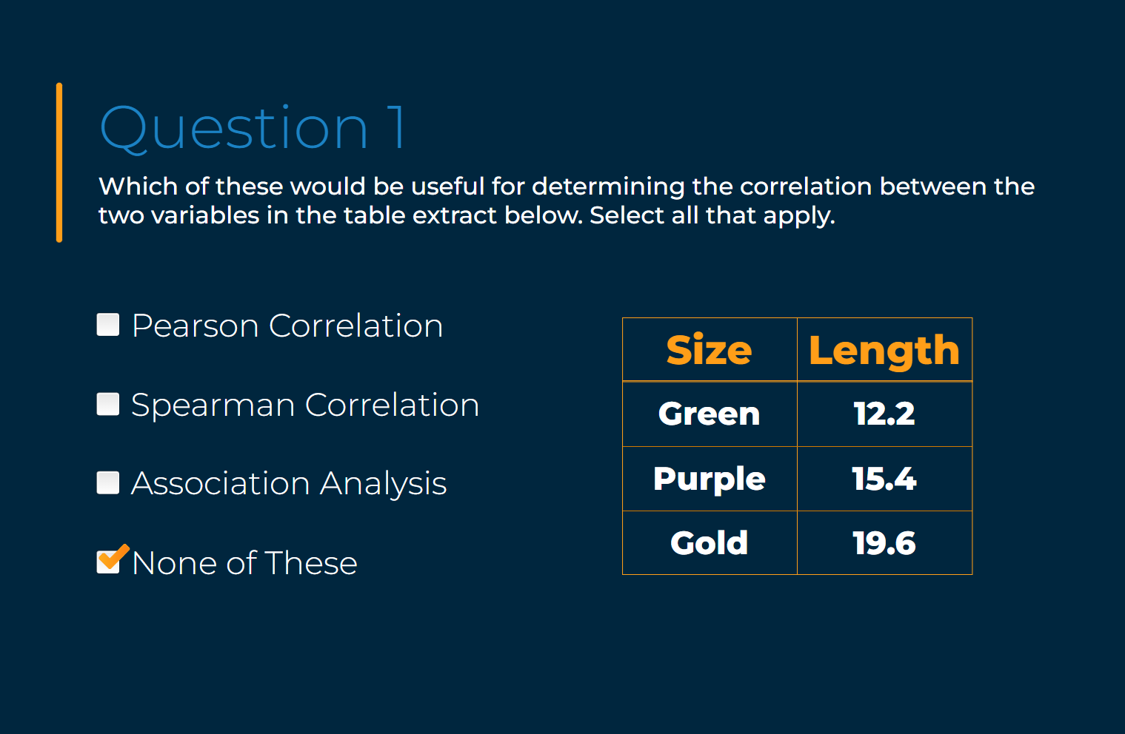

1. Data Investigation question.

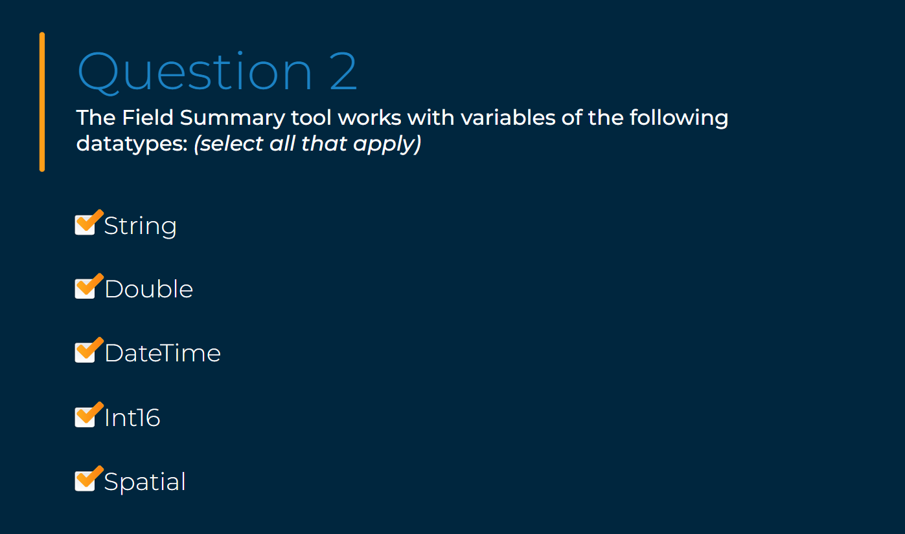

1. Data Investigation question.

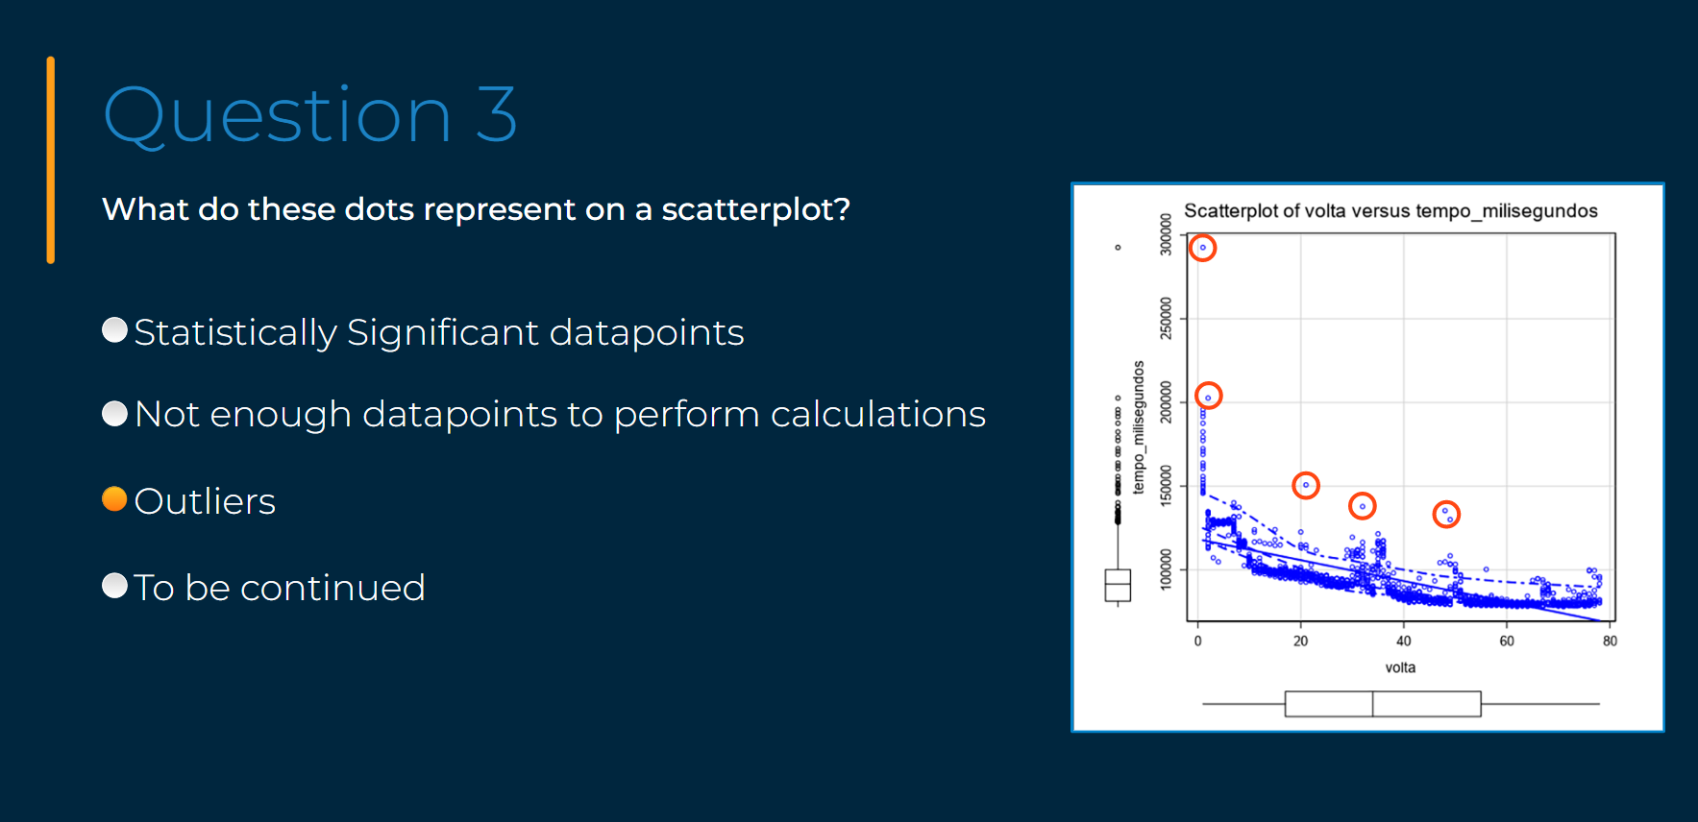

1. Data Investigation: removing fields that have only 1 unique value.

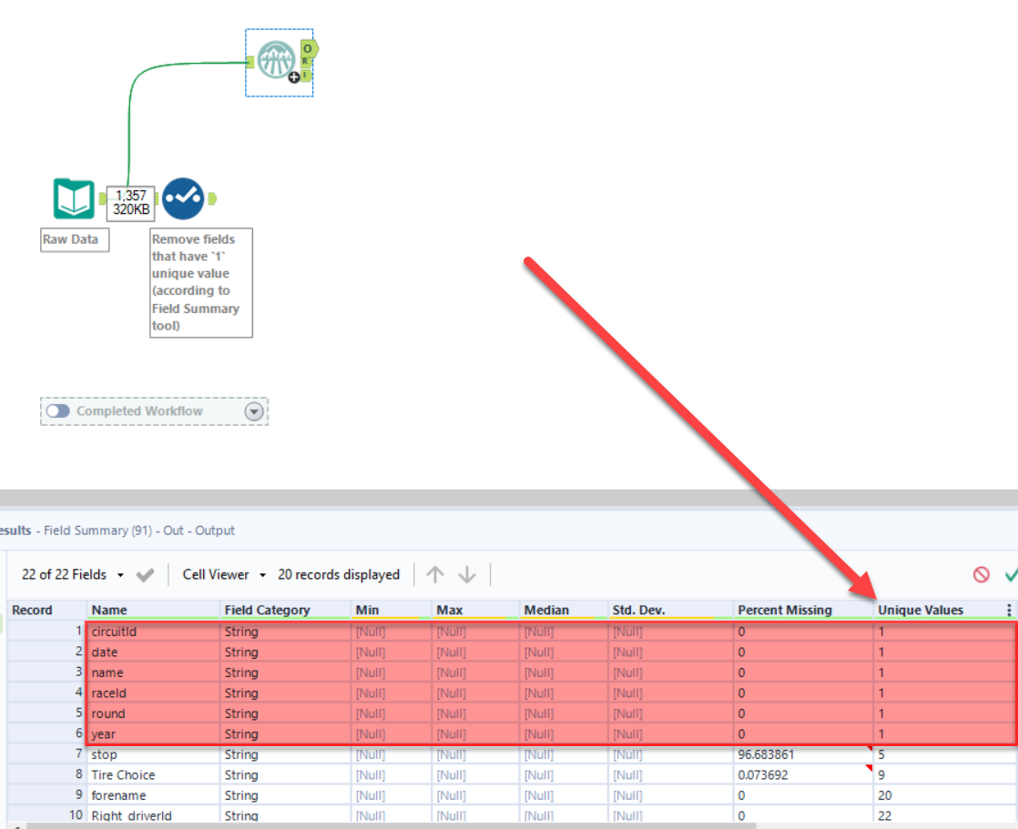

1. Data Investigation: removing fields that describe the same attribute (in this example, it’s 5 columns that describe the driver). Only the `code` field is kept.

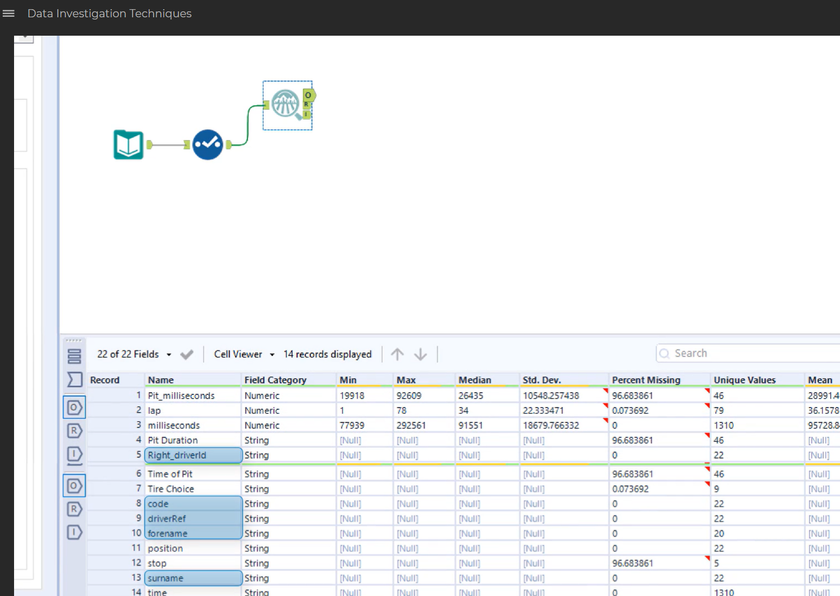

1. When you find bias.

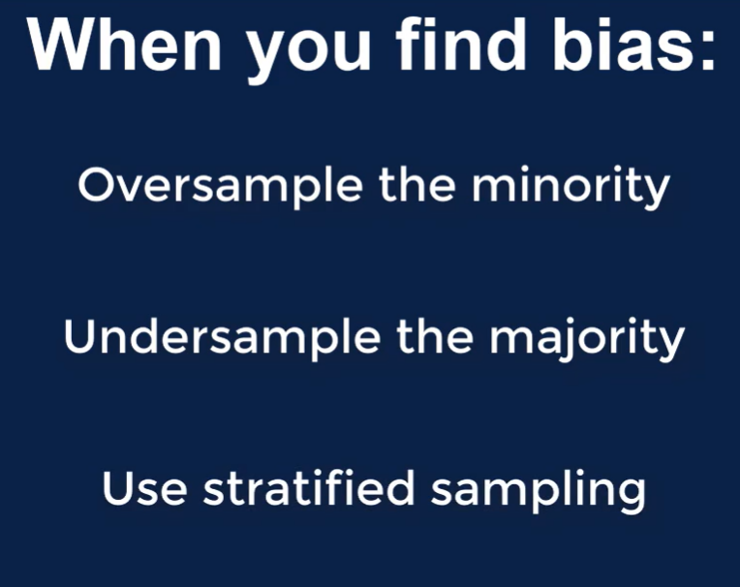

1. Correlation

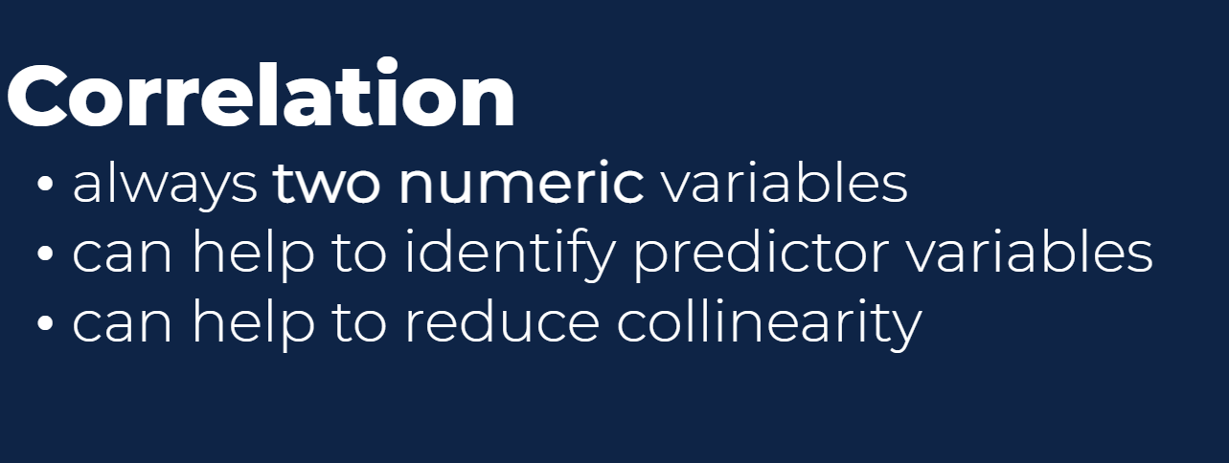

1. These Data Investigation tools can be used to find numeric relationships only.



1. These tools (i.e., Plot of Means and Test of Means) can show relationships between continuous and categorical variables.



Example:

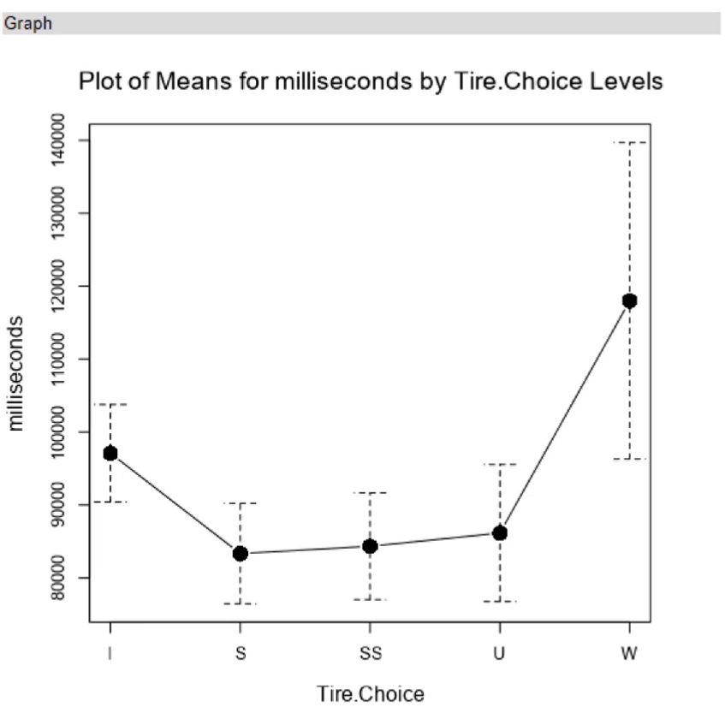

Example:

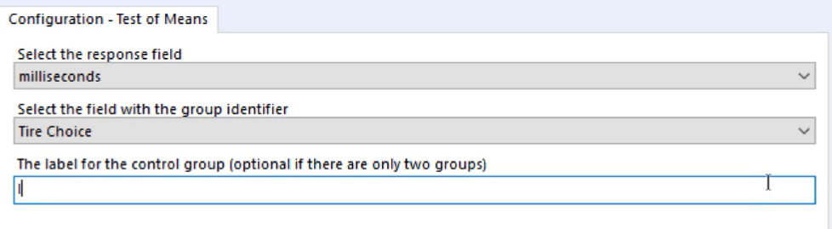

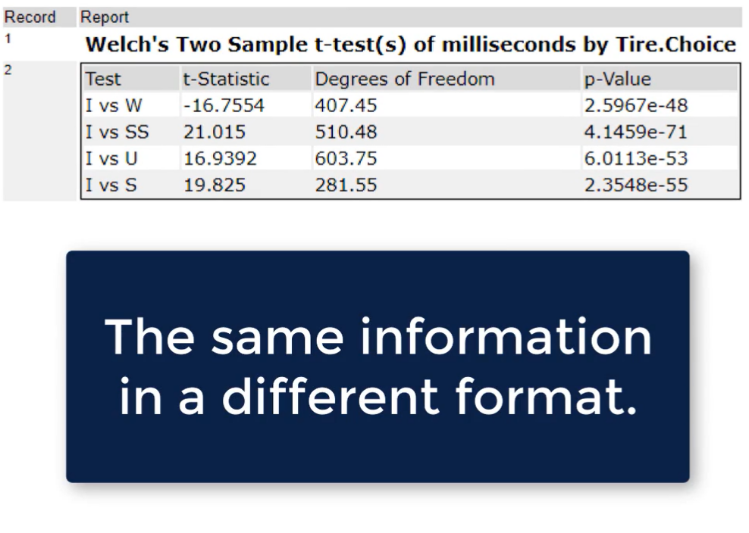

1. To test relationships between two categorical variables, the Contingency Table tool can be used.



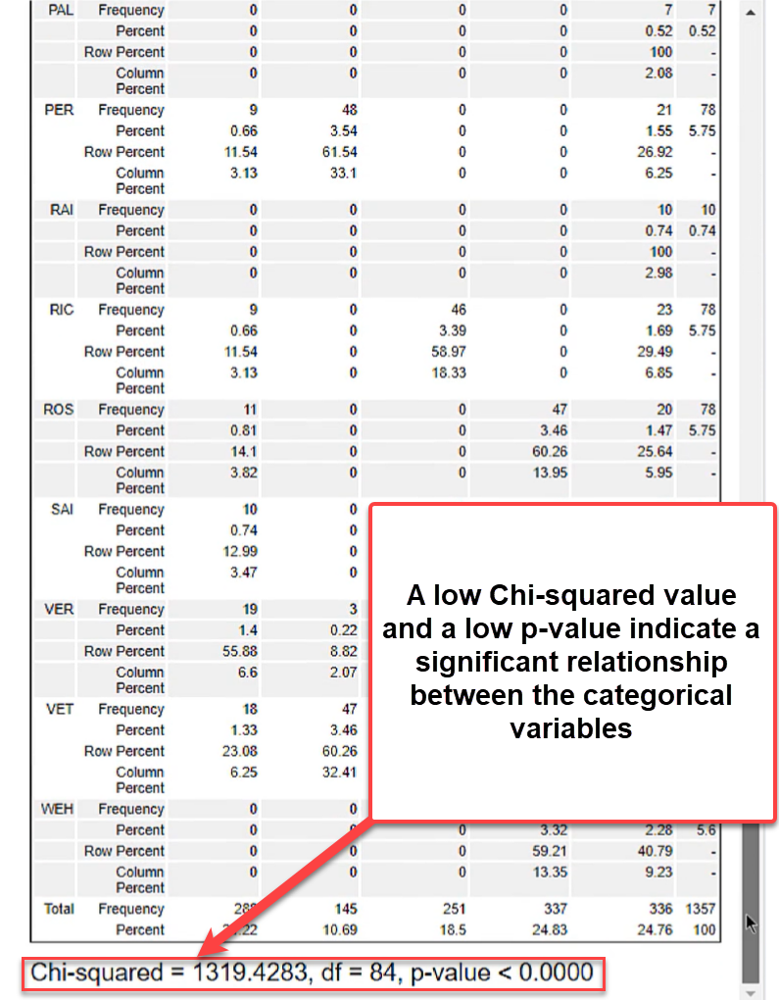

1. Predictor variables.

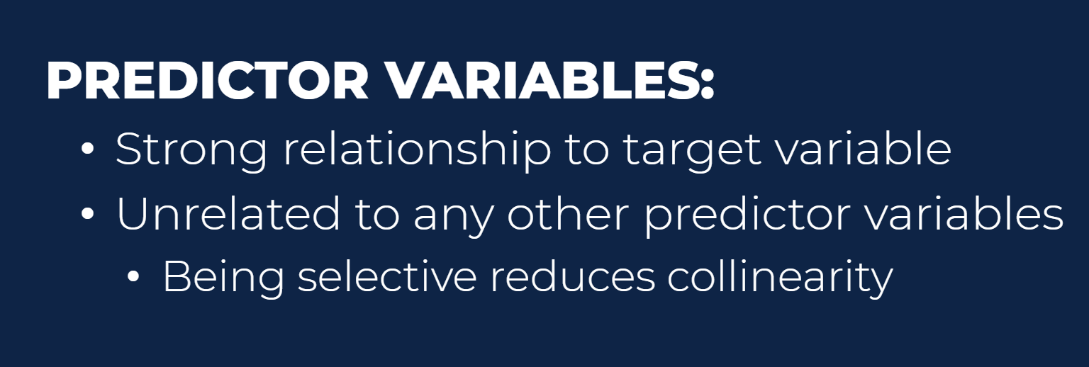

1. Feature selection

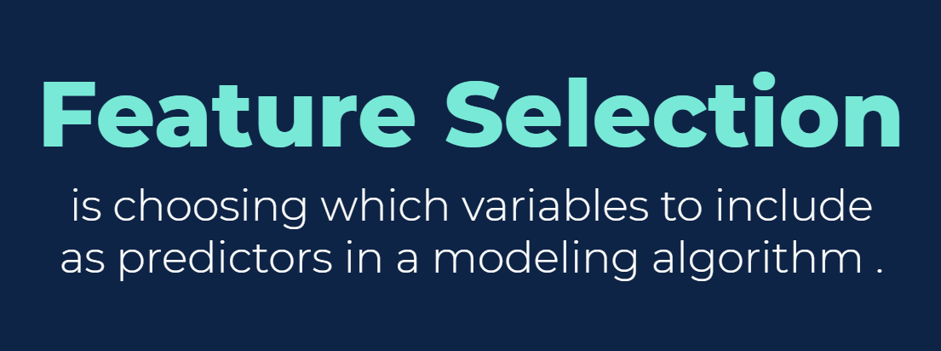

1. Logistic regression

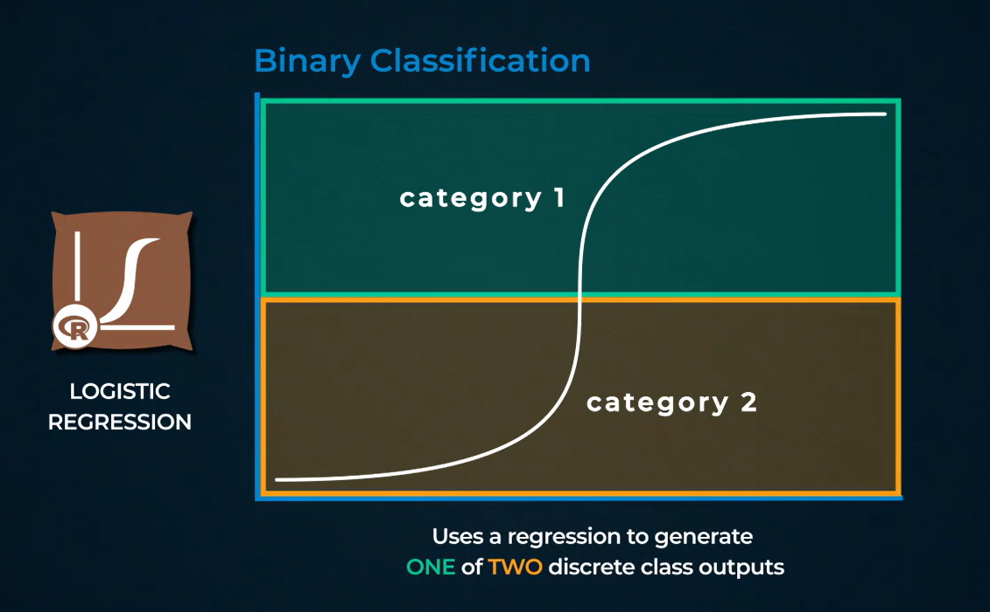

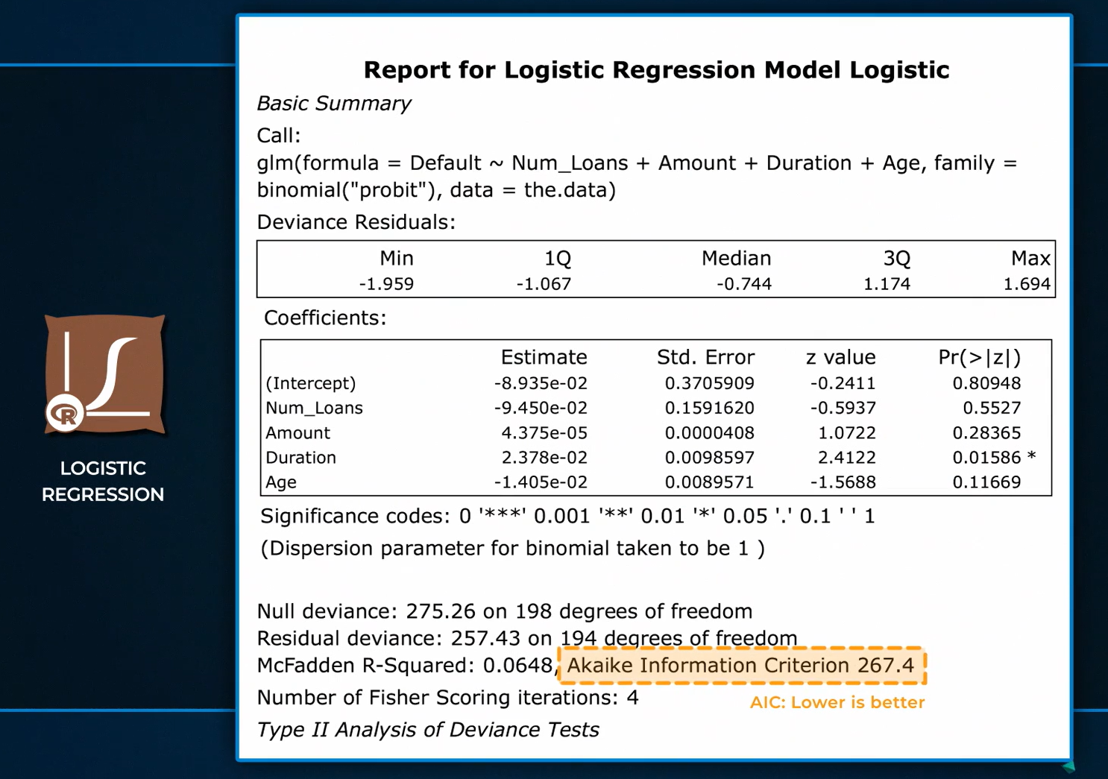

1. Linear Regression. The R-squared statistic ranges from 0 to 1; it measures how much of the variance in the target (i.e., dependent) variable is accounted for by the model. The Adjusted R-squared accounts for the number of variables in the model and can be more representative of the model’s performance.

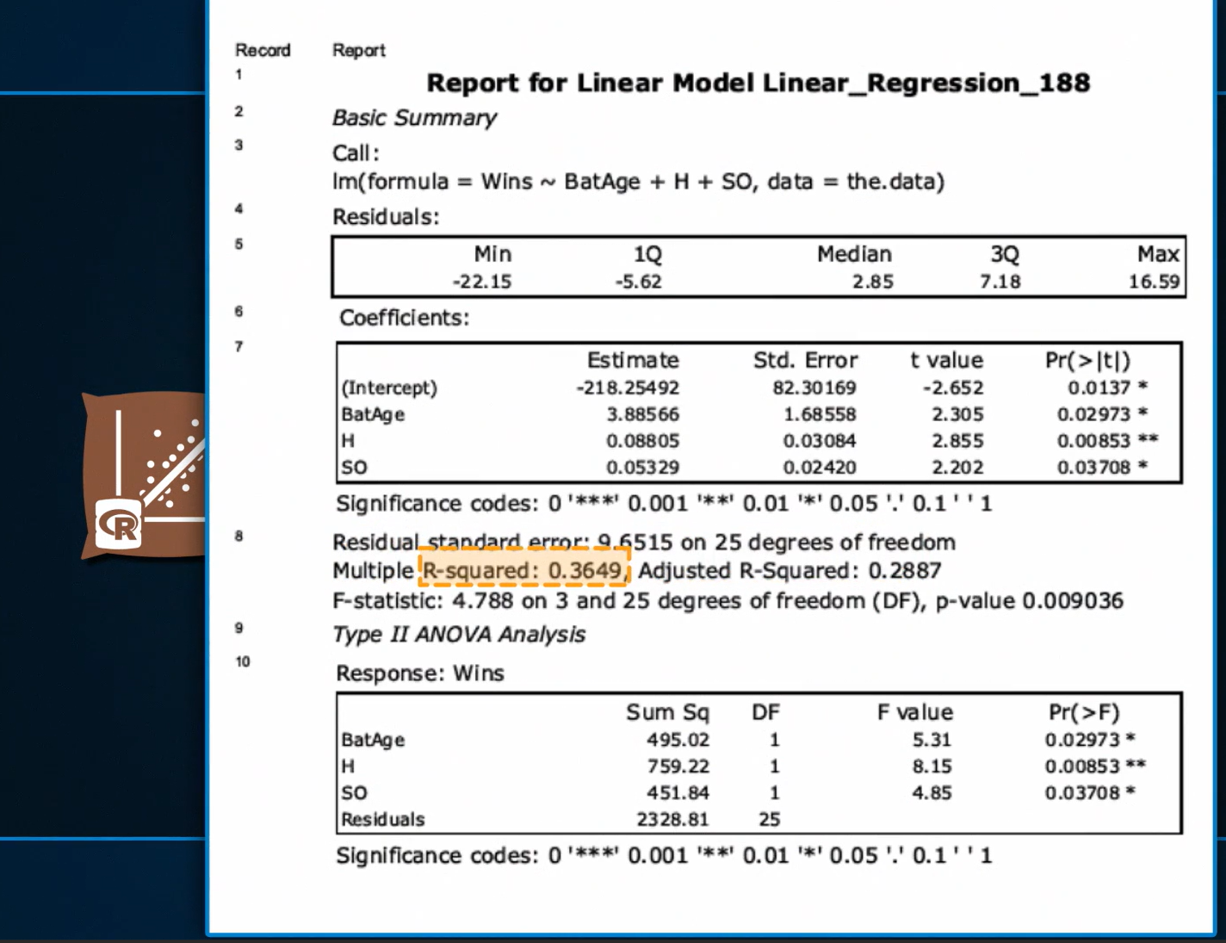

1. Naïve Bayes. Called naïve because it assumes all predictor (i.e., independent) variables are totally independent.

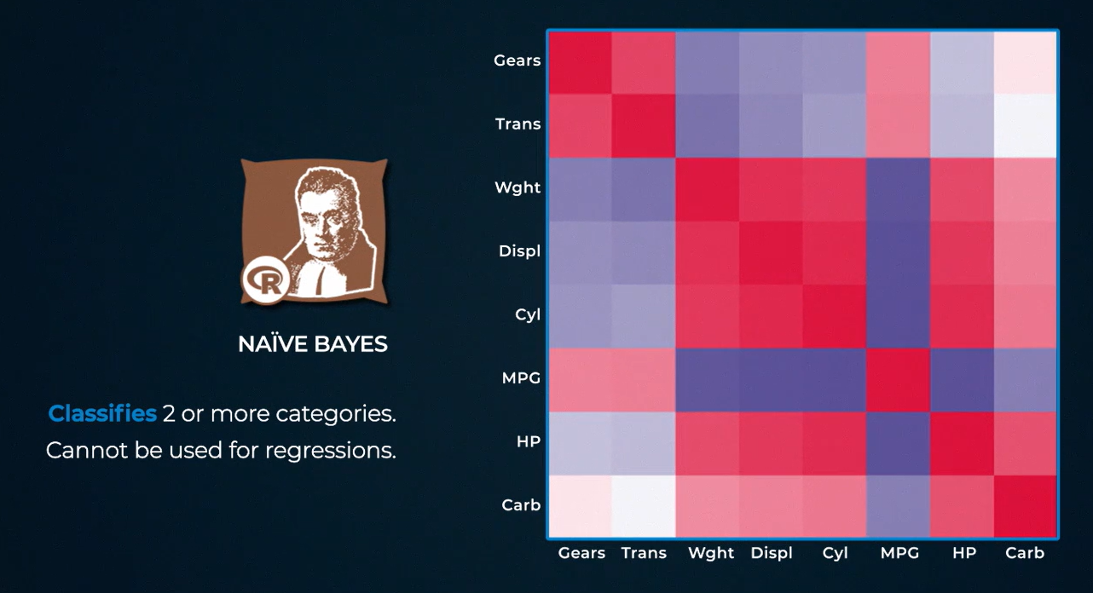



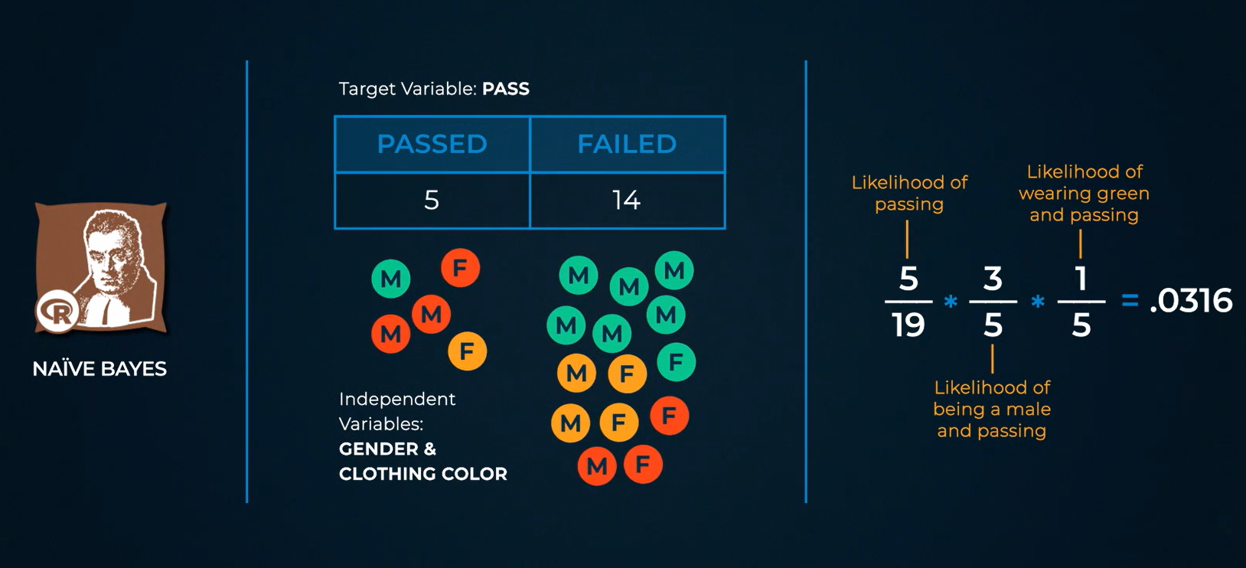

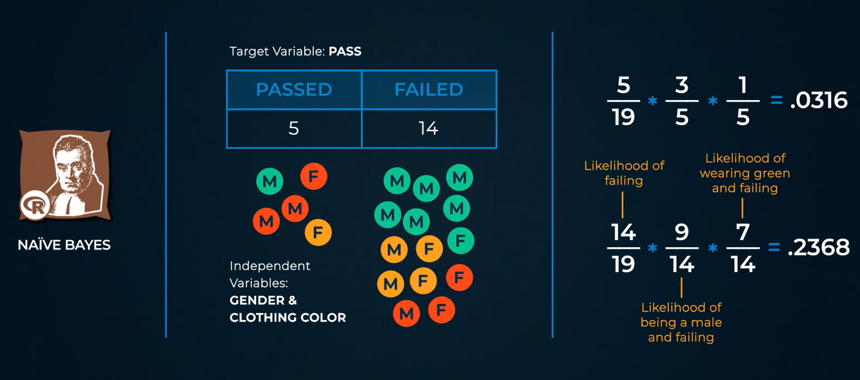

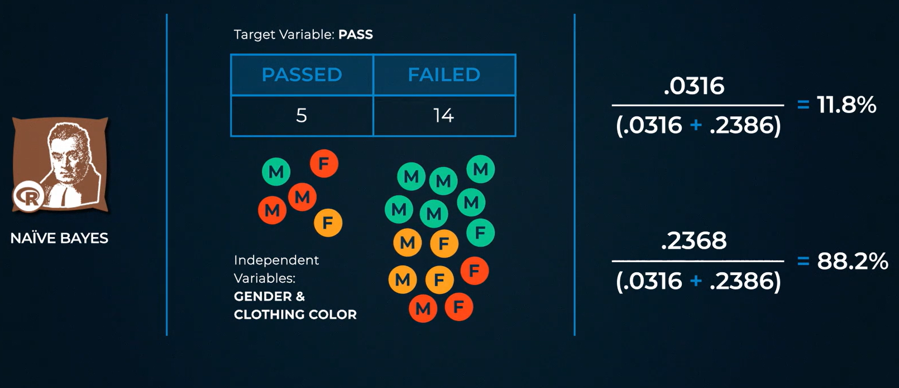

1. Decision Tree

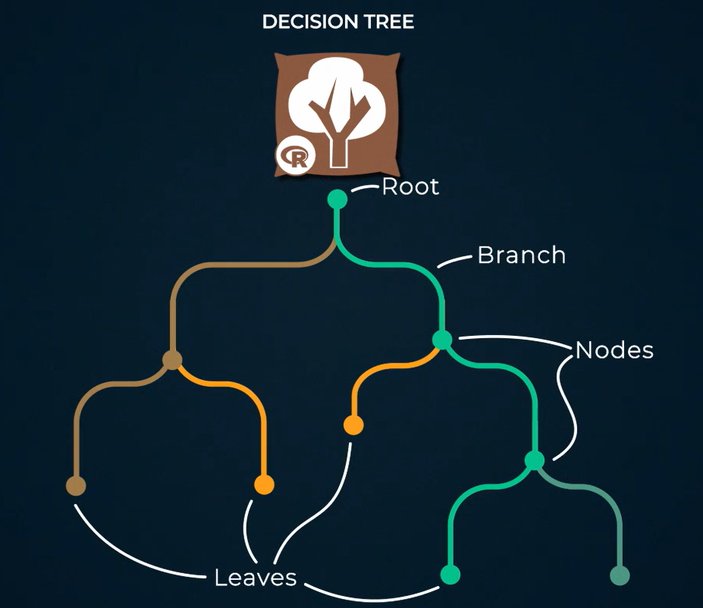

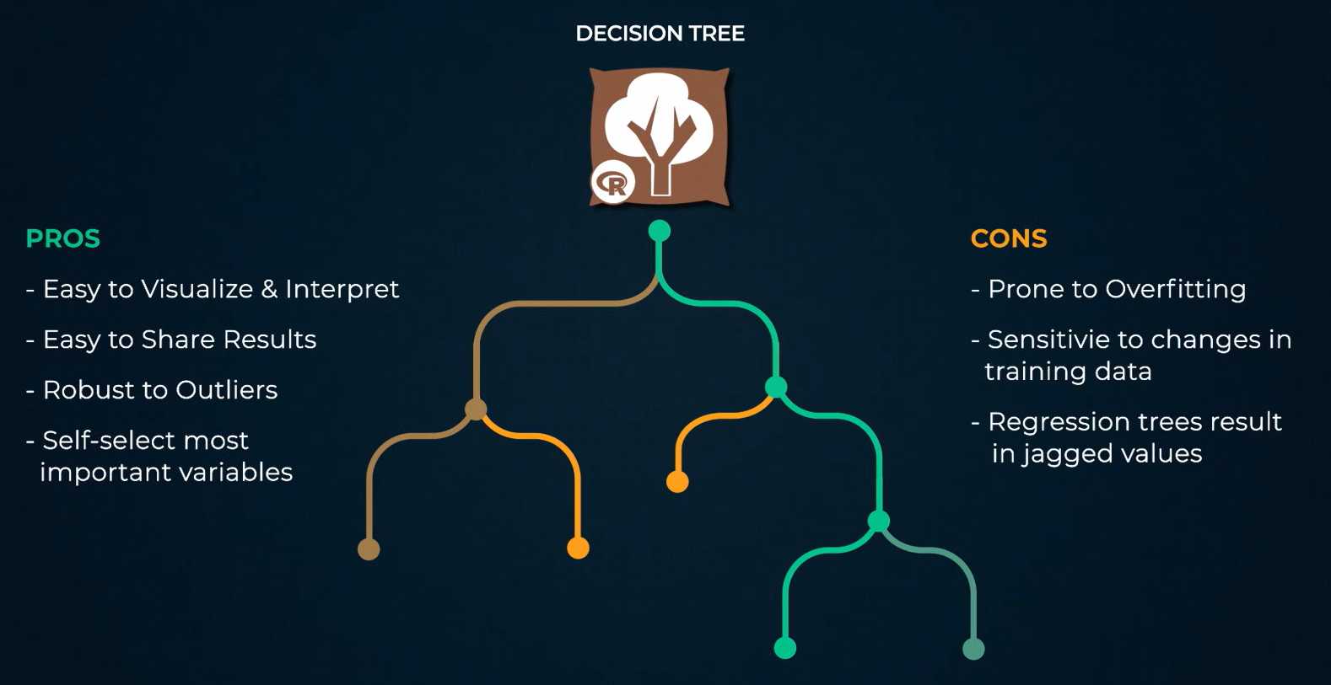

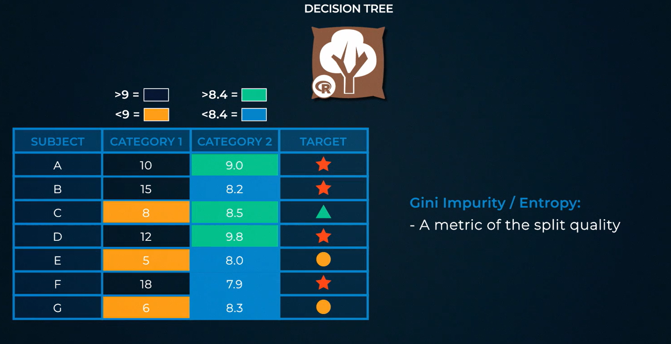

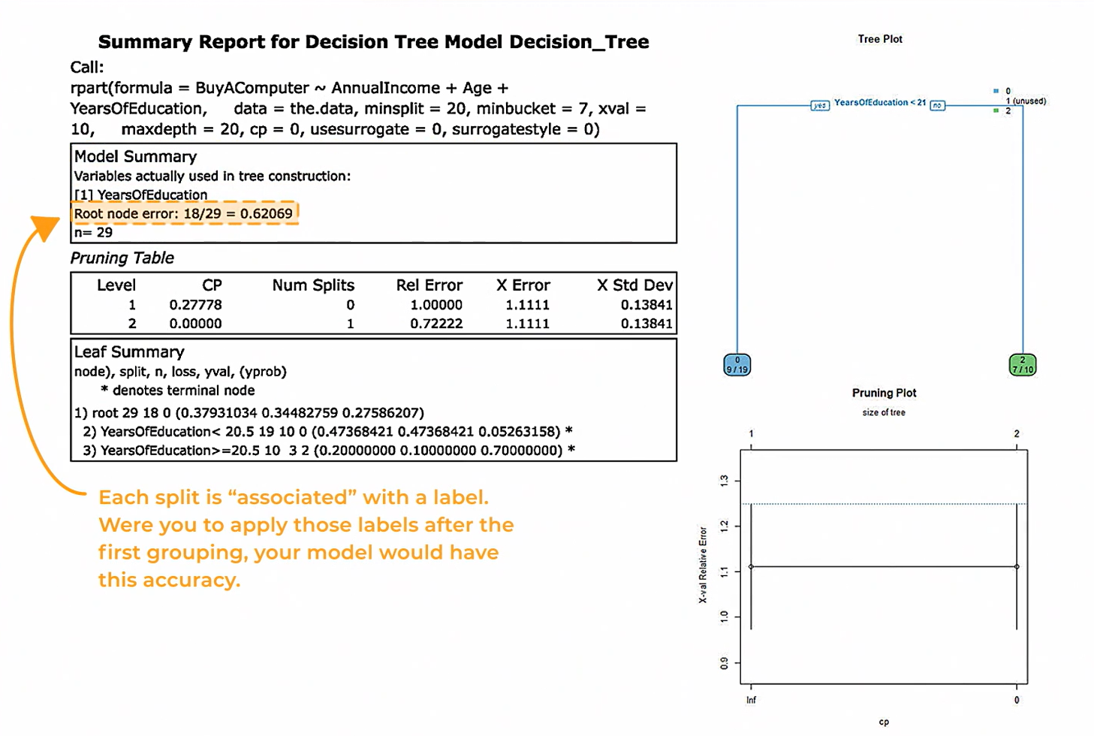

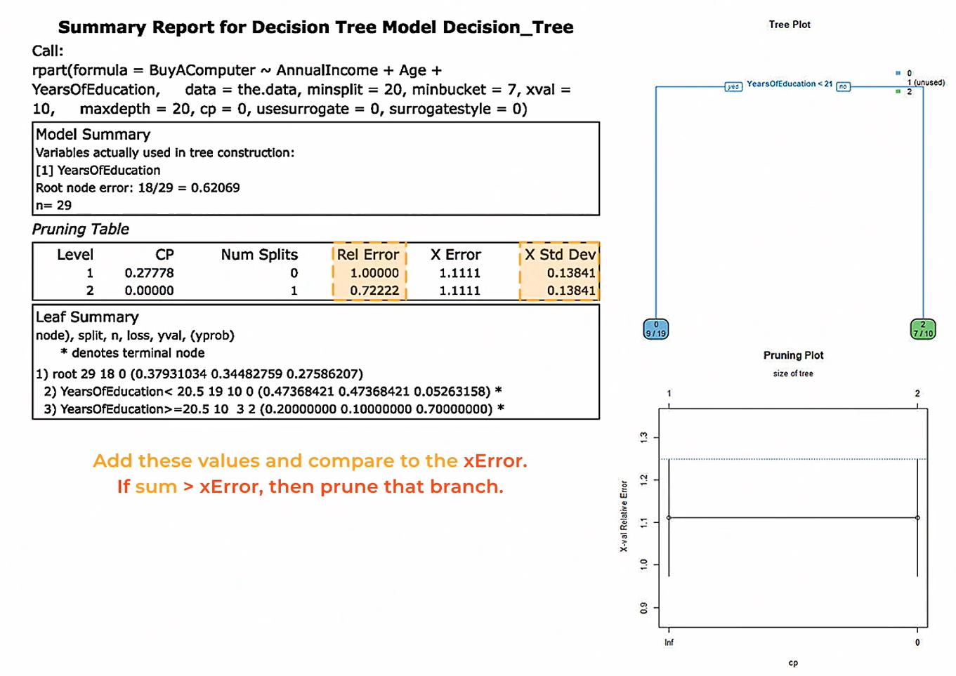

1. Forest model

